Project Proposal – D&D Character Manager

Our goal is to create an app that allows digitally create character sheets for Dungeons & Dragons that can be created and maintained easily from the comfort of their computers. The form will consist of text fields and combo boxes for most of the elements as well as an option between an image uploader and a character creator for the character profile. We will use validation for each field, events for many of the elements to work. Additionally, we will use validation to make sure the player enters appropriate data in each field and all attributes have a value so the player doesn’t miss anything.

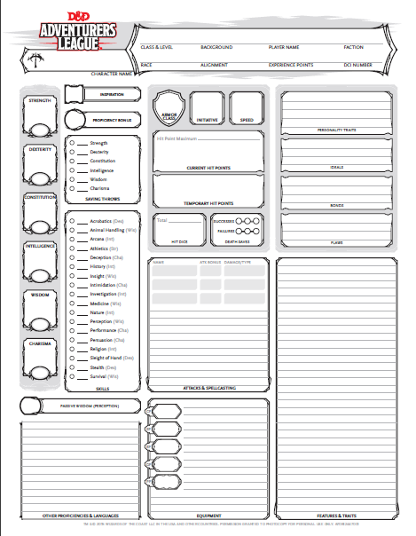

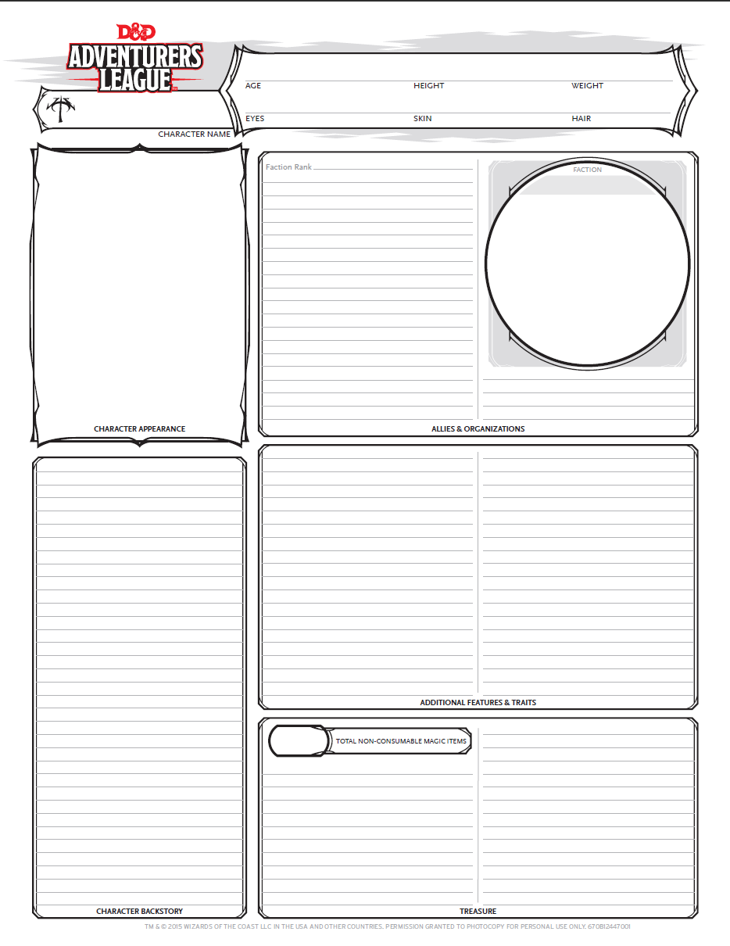

**Group Members:**

Kevin Meisenbacher

James Spoor

Lakshika Bhanusali

Shalu Sharma